**IT 542: Pattern Recognition and Machine Learning**

**Assignment 1**

ID:201811024

Name- Rajat Kumar

1. Draw 100 samples from uni-variate Normal distribution, plot its histogram. Compute pdf for univariate normal distribution and compare it with histogram. Repeat experiment with 500, 1000 data points.

**Output:**

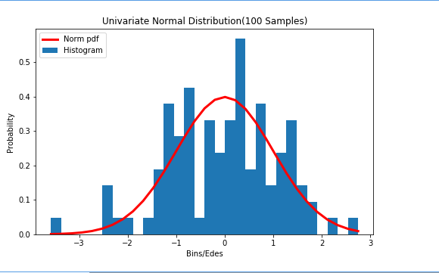

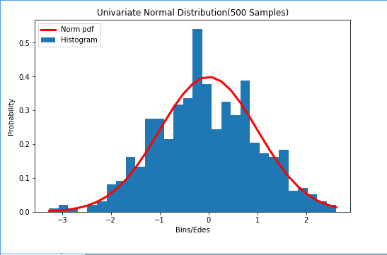

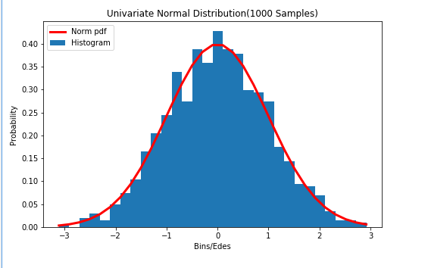

1. Draw 100 samples from bi-variate Normal distribution. Repeat experiment 1.

**Output: A) 100 Samples**

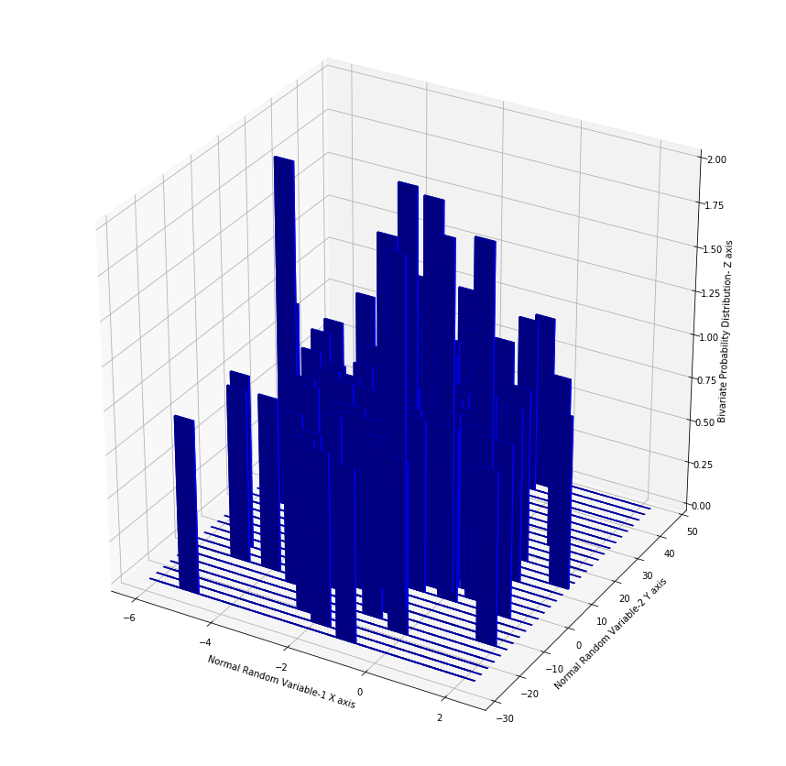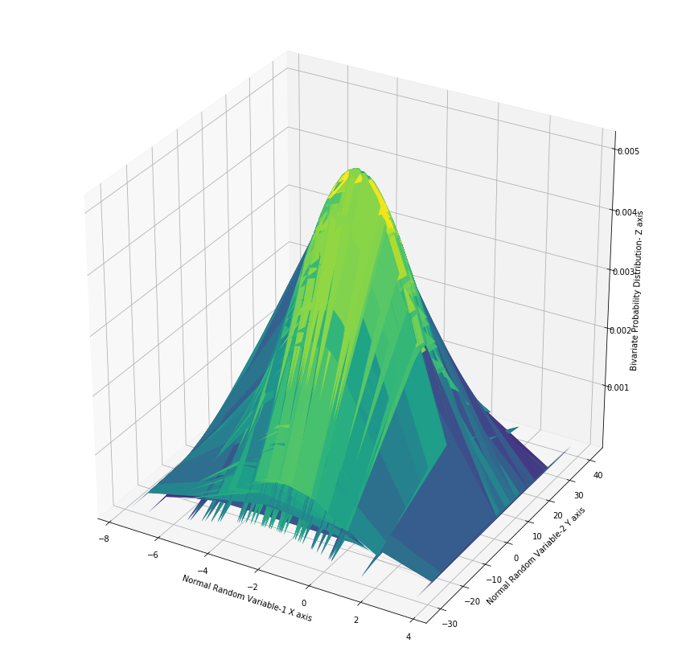

1. **500 Samples**

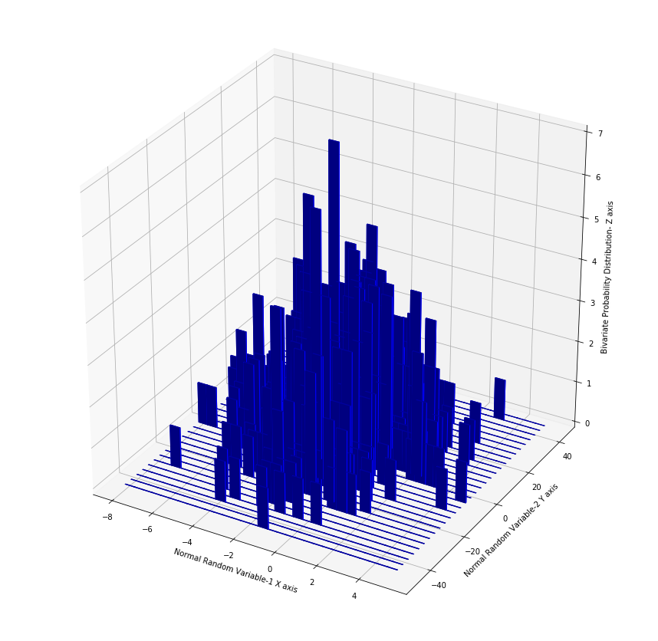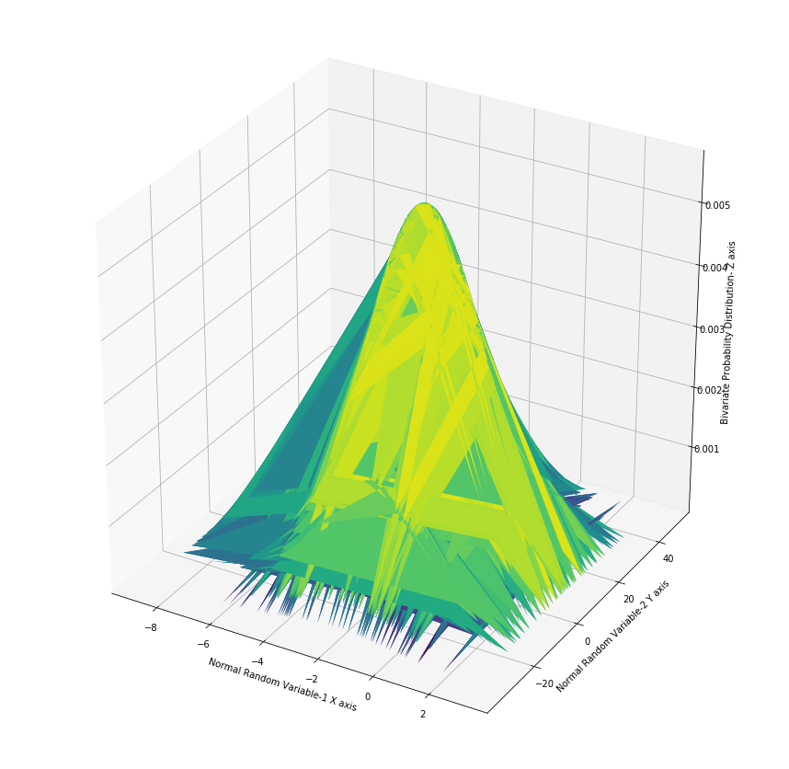

1. **1000 Samples**

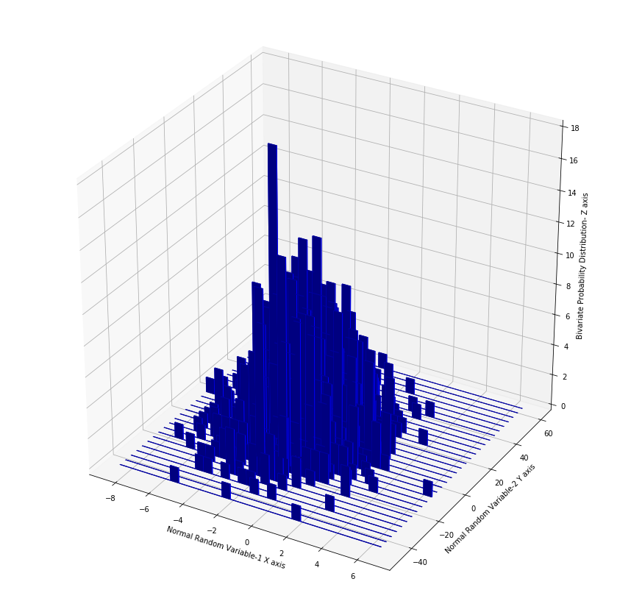

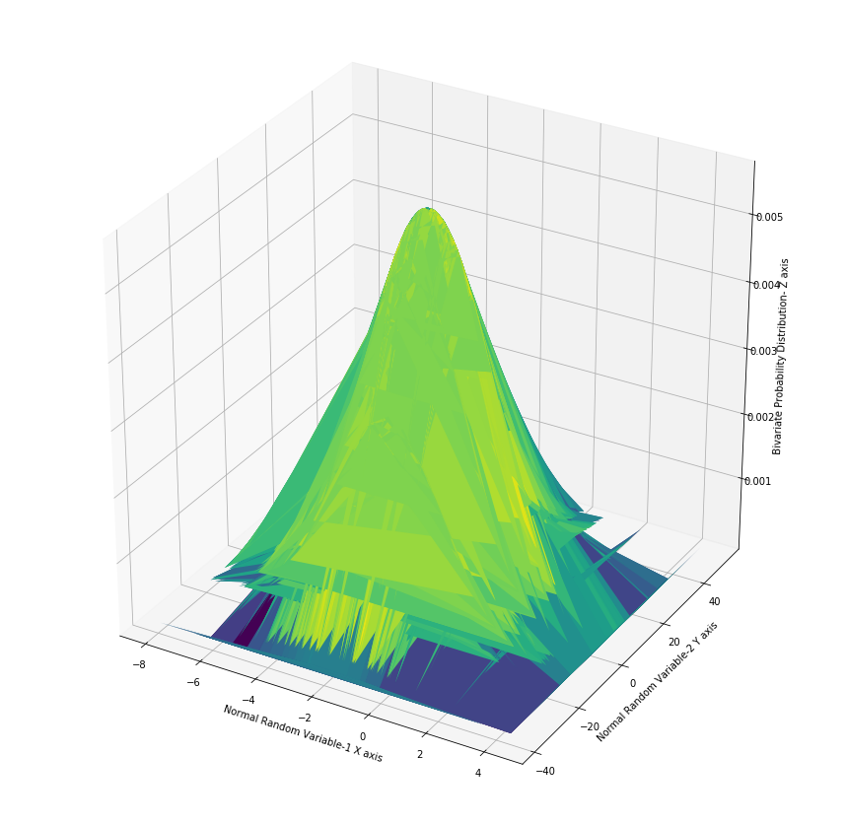

(3) Do following

a. Implement central limit theorem.

b. Draw 12 samples from Uni[0,1] as a sample population and perform CLT. Observe the distribution of sample means.

**Output: a) Random Variable Size=1000 X 1**

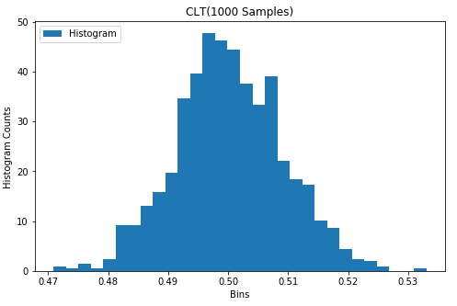

**Output: b) 12 Monte Carlo Simulations:**

**Each Simulation: 1000 Uniform Random Variables taken and their means are computed to plot the distribution.**



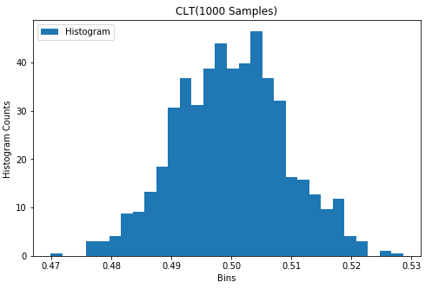

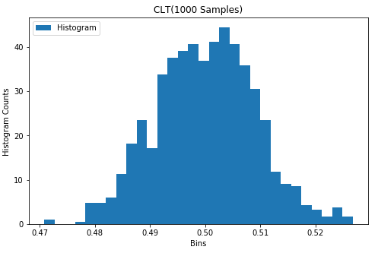

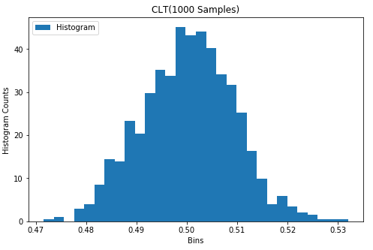

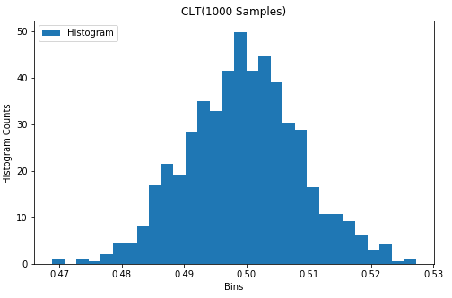

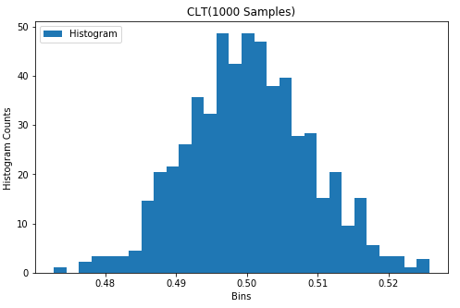

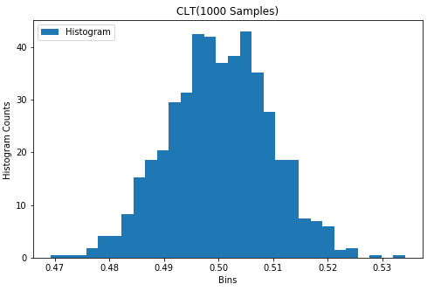

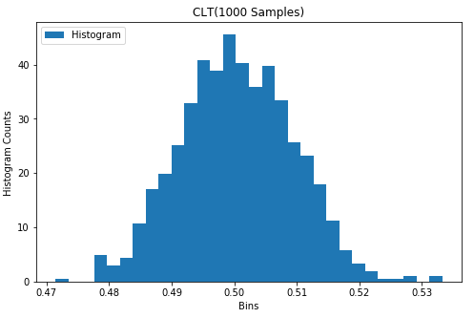

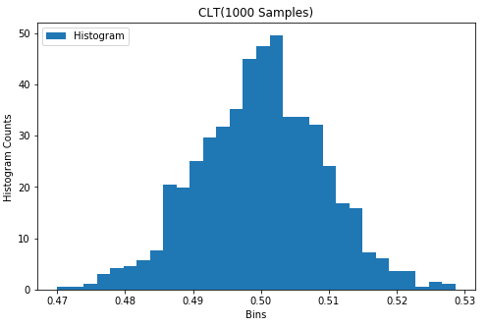

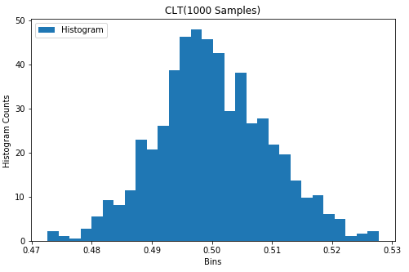

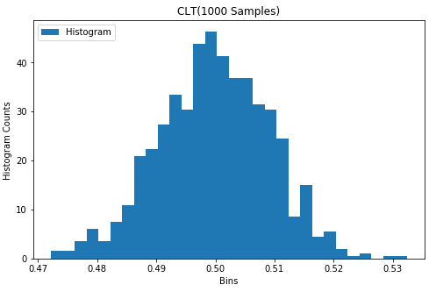

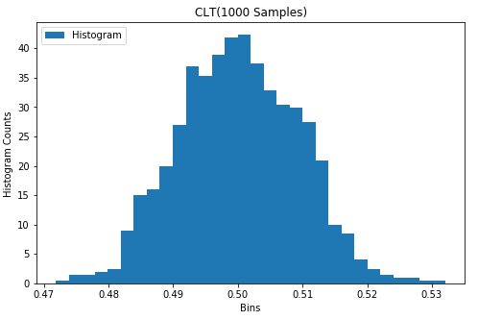

Note: These come to be Gaussian, even if the sample was drawn from a uniform distribution

1. Use Box-Muller method to achieve Normal distribution.

Output:

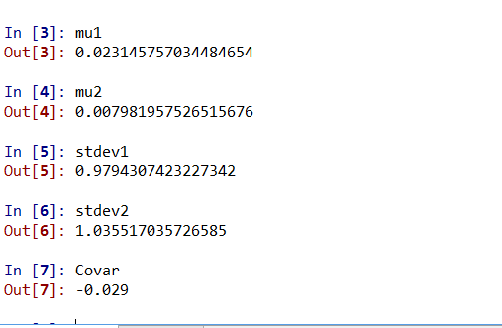

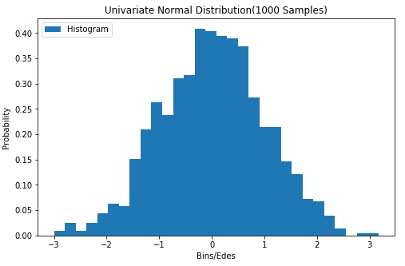

Note: Got 2 Gaussian random variables of size 1000X1.

Both are independent as their covariance is nearly 0.

And Both are standard normal as their mean is nearly 0, and variance is nearly 1.